600086 Lab Book

# Week 2 – Lab B

Date: 17th Feb 2022

## Q1. Understand the block and thread indices

### Question:

### Solution:

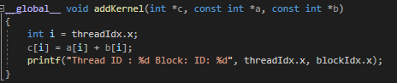

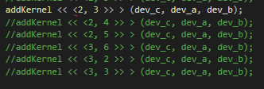

### Test data:



### Sample output:

|  |  |
| --- | --- |
| Thread Config | Output |
| addKernel <<<2, 3 >>> (dev_c, dev_a, dev_b); |  |
| addKernel <<<2, 4 >>> (dev_c, dev_a, dev_b); |  |
| addKernel <<<2, 5 >>> (dev_c, dev_a, dev_b); |  |
| addKernel <<<2, 6 >>> (dev_c, dev_a, dev_b); |  |
| addKernel <<<3, 2 >>> (dev_c, dev_a, dev_b); |  |
| addKernel << <3, 3 >> > (dev_c, dev_a, dev_b); |  |

### Reflection:

The output variables seems to be dependent upon the number of threads per block rather than the number of thread blocks. The aim of this task was to wexperiment with how changing the amount of threads/threadblocks affects the output from the program.

### Metadata:

Threadidx.x, blockidx.x

### Further information:

## Q2. Exercise 2. Find vector addition using multiple 1D thread blocks

### Question:

### Solution:





### Test data:



### Sample output:

|  |  |
| --- | --- |
| Thread Config | Output |
| addKernel <<<2, 3 >>> (dev_c, dev_a, dev_b); |  |
| addKernel <<<2, 4 >>> (dev_c, dev_a, dev_b); |  |
| addKernel <<<2, 5 >>> (dev_c, dev_a, dev_b); |  |
| addKernel <<<2, 6 >>> (dev_c, dev_a, dev_b); |  |
| addKernel <<<3, 2 >>> (dev_c, dev_a, dev_b); |  |
| addKernel << <3, 3 >> > (dev_c, dev_a, dev_b); |  |

### Reflection:

The output variables seems to be dependent upon the number of threads per block rather than the number of thread blocks. The aim of this task was to wexperiment with how changing the amount of threads/threadblocks affects the output from the program.

### Metadata:

### Further information: